Learning & Participation
Job Description: Dance Animateur (East region)

BACKGROUND INFORMATION
Rambert is Britain’s national contemporary dance company. Under the award-winning artistic direction of Mark Baldwin, Rambert tours throughout the UK and overseas, producing an unrivalled quantity of new work for large-scale stages. Established in 1926 by Polish émigré Marie Rambert, the Company continues to build on its rich heritage to deliver performances full of ideas and passion.

Rambert’s 22 dancers are considered to be some of the finest and most versatile in the world, meeting the challenge of performing a range of styles with flair and precision. Committed to ensuring the development of dance for future generations, Rambert seeks out and nurtures new choreographers, including from within its own ranks. The Company believes that exciting and innovative dance is created through bold collaborations between choreographers and composers, designers and visual artists, and tours with its own chamber orchestra.

Rambert provides a vibrant and accessible dance experience and is committed to engaging people of all ages through an extensive, national programme of activities to encourage learning and participation.

In 2013 Rambert moved to new, purpose-built, RIBA award-winning headquarters in the heart of London’s South Bank, following the successful conclusion of a £14.6 million fundraising campaign. The building was officially opened in March 2014 by HM The Queen accompanied by HRH the Duke of Edinburgh.

This is an exciting time for an ambitious individual to be part of the next chapter of Rambert’s history, helping the Company to realise its full potential.

Learning & Participation

Drawing on the resources of the company’s artists, repertoire and heritage, the learning and participation department creates opportunities for people of all ages and abilities to engage with Rambert and develop their appreciation of contemporary dance. Current areas of work include an extensive workshop activities for schools and colleges across the UK, a programme of events in theatres, a dance and health programme (with a particular focus on older adults), annual holiday courses and evening classes. The department runs more than 800 workshops and events per annum, engaging over 30,000 people.

The Director of Creative Projects oversees the department, which is made up of a Manager (part-time), Coordinator (full-time) and Elders Programme Coordinator (part-time) and a pool of animateurs. The animateurs are professionally trained dance specialists who deliver dance sessions to our participants.

A large part of our work is repertoire based, with an understanding of curriculum demands within the education system. The through-line in all our sessions is to enable participants to explore the company’s rich heritage and be inspired by its innovative contribution to the development of dance.

For more information on our learning and participation work, please visit: www.rambert.org.uk

Animateur (East region)
Rambert is working with DanceEast and Theatre Royal Norwich to recruit a small pool of animateurs based in the East of England to deliver a range of learning and participation activities in schools and community settings.

The work of an animateur is challenging and exciting; teaching in a variety of settings to people from a wide variety of backgrounds. Many of our workshops take place in schools and colleges, and a substantial amount of work takes place in healthcare settings such as hospitals and day centres. Sessions are delivered over weekday and weekend courses and occasionally week long residencies.

Animateur training will either take place at the company studios on London’s South Bank or a venue in the East region. The training includes learning parts of the repertoire from dancers or rehearsal directors, discussing teaching methods and ideas, as well as a warm-up class. Animateurs are also invited to attend rehearsals, performances and company meetings to deepen their contextual understanding of the work.

Animateurs act as ambassadors for the company, and are often the main face-to-face point of contact for groups that we work with. An Animateur can work with up to 300 people a week, many of whom will also be audience members for Rambert and who will have a greater understanding and enjoyment of the performance as a direct consequence of their workshop.

The Job

The animateur will be expected to:

- Be in contact with department in advance of all workshops, residencies and projects to confirm the organisation and content of the session.

- Undertake workshop planning and to familiarise her/himself with the Company's repertoire during pre-arranged preparation days to deliver the highest quality of experience for participants. Workshop plans are to be devised in consultation with the Director of Creative Projects and/or Learning & Participation Manager and other freelance company animateurs as required.

- Deliver a variety of different types of dance activity that can include one-off workshops, courses last a few days or weeks and creating choreography on participants.

- Travel across the region to lead sessions in various schools, colleges, venues and community centres based on the company repertoire. This will be by via animateur’s own transport or public transport.

- Attend at least one Rambert performances per tour.

- Contribute to the development of learning and participation programme and its resources, completing feedback, monitoring (where required) and attending planning meetings as requested.

Skills and knowledge

Essential
The freelance company animateur will be a motivated and experienced dance artist with the ability to teach a wide range of groups from the ages of 2 – 60+ years from various backgrounds including; beginners, primary school children, students studying GCSE, AS/A-Level and Degree level to older adults.

This means that they will demonstrate:

- A minimum of 2 years’ experience of teaching contemporary dance in a participatory setting that includes young people.

- Strong contemporary dance technique and the ability to demonstrate Rambert repertoire accurately, with a focus on Cunningham technique.

- Versatility to adapt workshop material in a positive way to enable any participant to achieve the learning outcomes.

- Experience in working creatively with a wide range of participants.

- Choreographic skills in a community and education setting.

- Enthusiasm for and a basic knowledge of the work of the Company.

- Good communication skills.

- Empathy for participants, their group leaders and the environment in which they are teaching.

- Independence and initiative as well as being capable of working as part of a team.

- Good knowledge of contemporary dance and its place in the education system, particularly in relation to the National Curriculum and requirements for dance.

- Flexibility to stay away from home for week long residencies and touring weeks.

Desirable

As the remit for our work is so wide desirable candidates will demonstrate:

- Experience of teaching sessions in healthcare settings and/or with older people.

- Possess a current driver’s licence and own transport.

Please note: The position will be subject to a clear enhanced disclosure check (DBS).

Terms of Employment
The animateur is employed on a freelance self-employed basis and is responsible for paying their personal tax and NI contributions. Fees are paid in arrears on presentation of an invoice to Rambert, on which their Unique Tax Code is stated. Rates of pay will be given to applicants selected for interview/audition.

Unless specified, travel and accommodation costs are claimed directly from Rambert by the animateur – the Director of Creative Projects will agree all overnight stays in advance. Rambert pays the touring allowance rates for opera/ballet companies as specified by the Theatrical Management Association (TMA). The rates vary per venue/area of the UK. Where possible travel to venues should be via public transport and the cheapest available fare, if travel by car is agreed mileage will be paid at the published rates.

Application Process

Please apply by providing a covering letter (of no more than 500 words) and a current CV stating how your skills and experience meet the requirements for this post, along with the equal opportunities form below.

Please also supply the names of two referees for whom you have delivered dance education work, stating at what stage of the process we may approach them for a reference. Selected candidates will be asked to take part in a recruitment day involving a class, repertoire and creative session and interview.

Please send applications to learning@rambert.org.uk (please put Animateur application in the subject line).

Closing date for applications: Monday 8 February 2016, 12pm
Recruitment day: Tuesday 16 February 2016, 11am – 4.30pm at the Jerwood DanceHouse, Ipswich.

Rambert is an equal opportunities employer and welcomes applications from all sections of the community.

Reg charity no. 326926

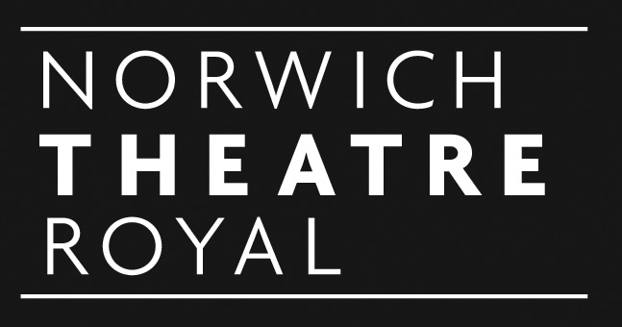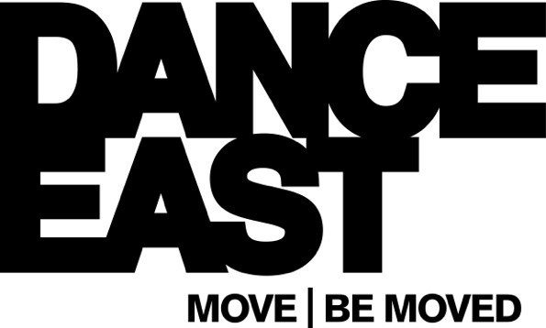


EQUAL OPPORTUNITIES MONITORING FORM

To assist with the implementation of our Equal Opportunities policy, please would you complete and return this form. It will be separated from your application and the information you give will be kept confidential from the selection panel. It will not be taken into account in any way, except for candidates with disabilities who meet the essential criteria, who will automatically be interviewed. The purpose of any future processing of this data will be to monitor the effectiveness of our Equal Opportunities policy, in a manner that maintains anonymity.

Position applied for: _____________________________________________

- How did you learn of the vacancy?

____________________________

- What gender are you? Female □ Male □

- What is your ethnic group?
NB these categories are recommended by the Commission for Racial Equality.
Choose ONE from section A to E, then tick the appropriate box to indicate your background.
A WHITE: British □
Irish □
Any other white background (please write in) ____________________________________

B MIXED: White and Black Caribbean □
White and Black African □
White and Asian □
Any other mixed background (please write in) ____________________________________

C ASIAN, ASIAN BRITISH: Indian □
Pakistani □
Bangladeshi □
Any other Asian background (please write in) ______________________

D BLACK, BLACK BRITISH: Caribbean □
African □
Any other Black background (please write in) _____________________

E CHINESE or other ethnic group: Chinese □
Any other background (please write in) _____________________

- What age group are you in?
16-21 □ 22-29 □ 30-39 □ 40-49 □ 50-59 □ 60+ □

- Do you consider yourself to be a disabled person? Yes □ No □
If so, do you have any access requirements and what are they?

Please write in _______________________________________________________

Thank you for completing this form

